Exercise 1: Implementing the Singleton Pattern

LogDriver.java

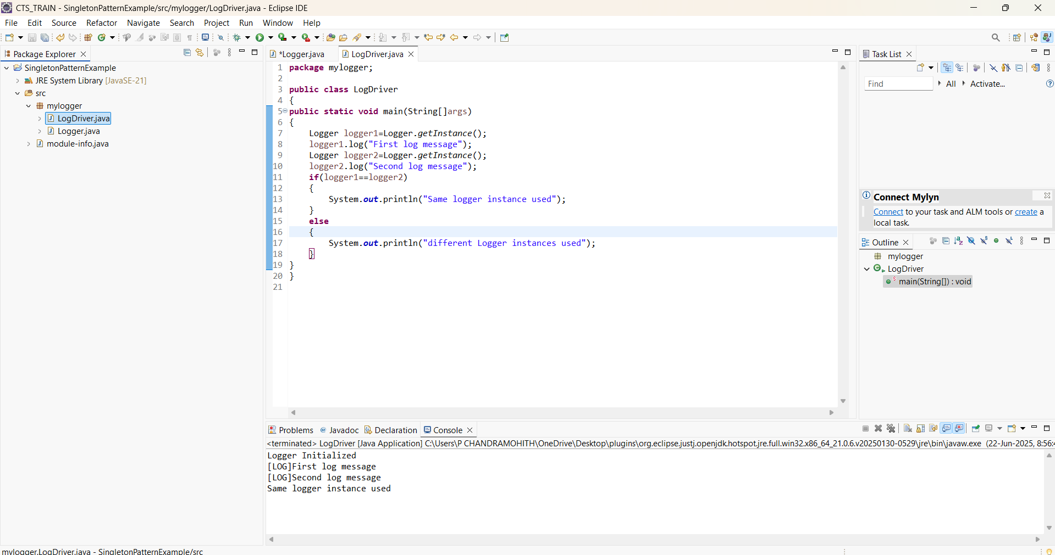

Logger.java

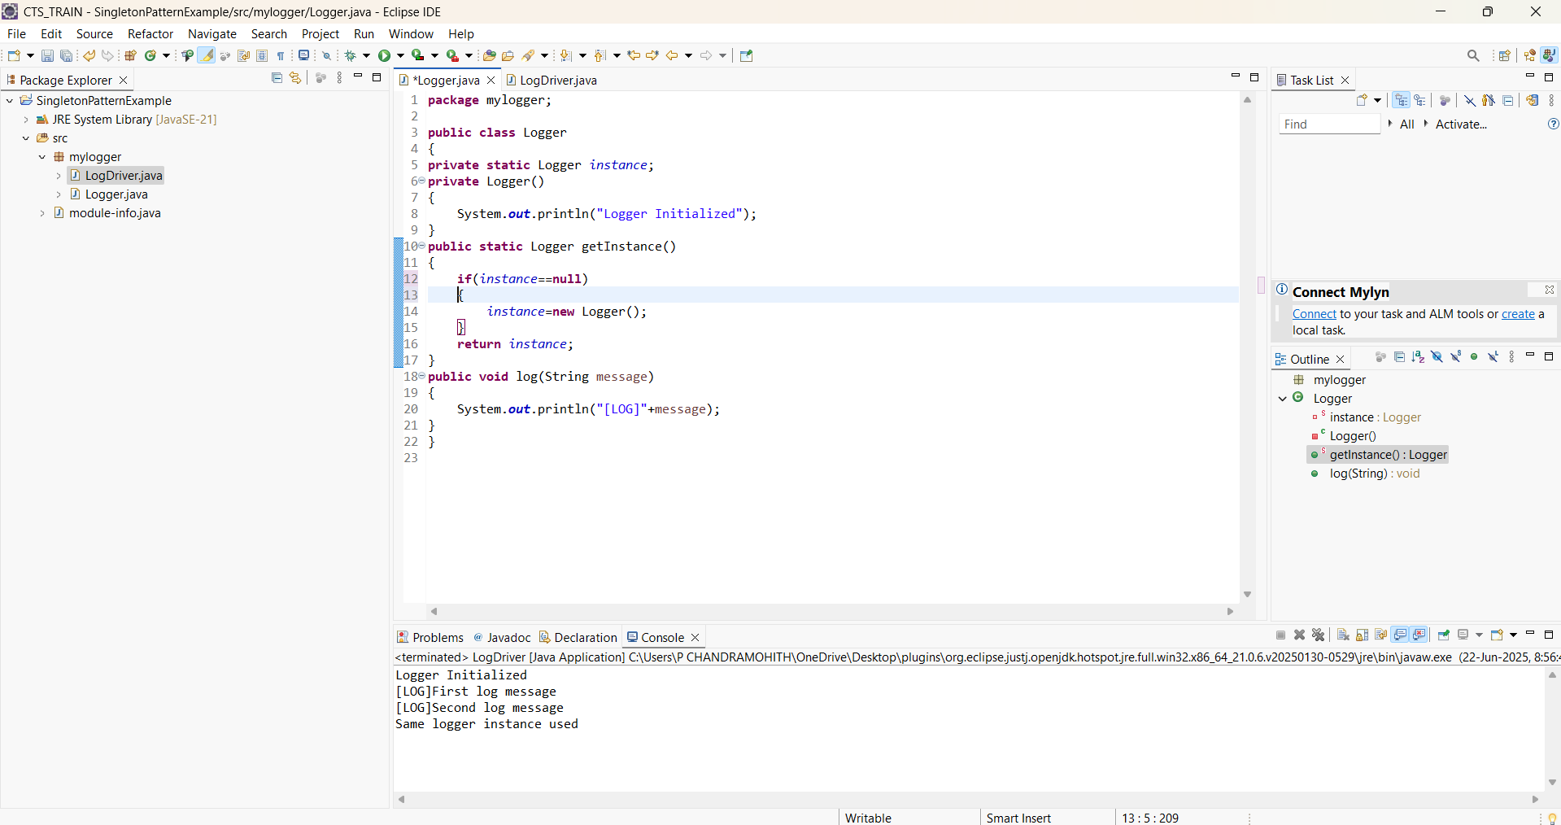

Exercise 2: Implementing the Factory Method Pattern

NotificationFactory.java

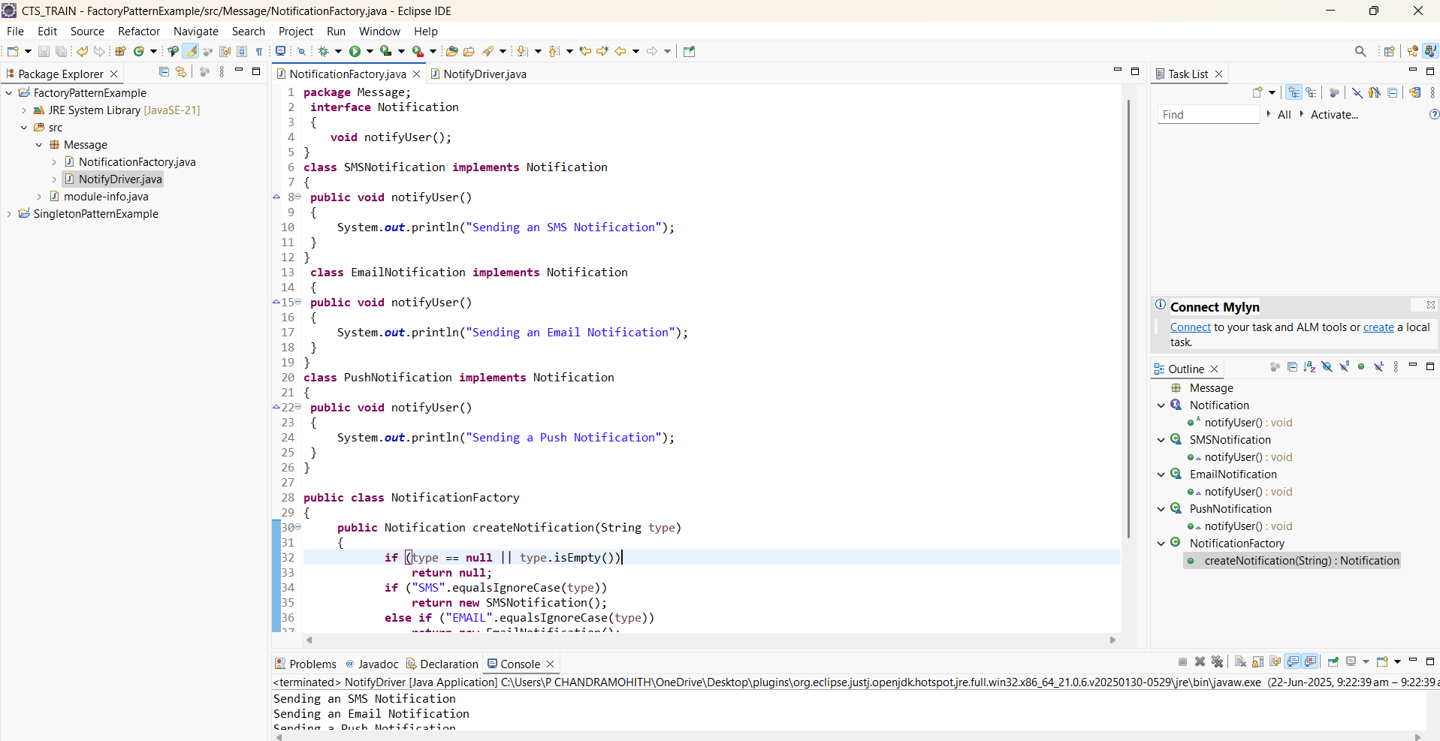

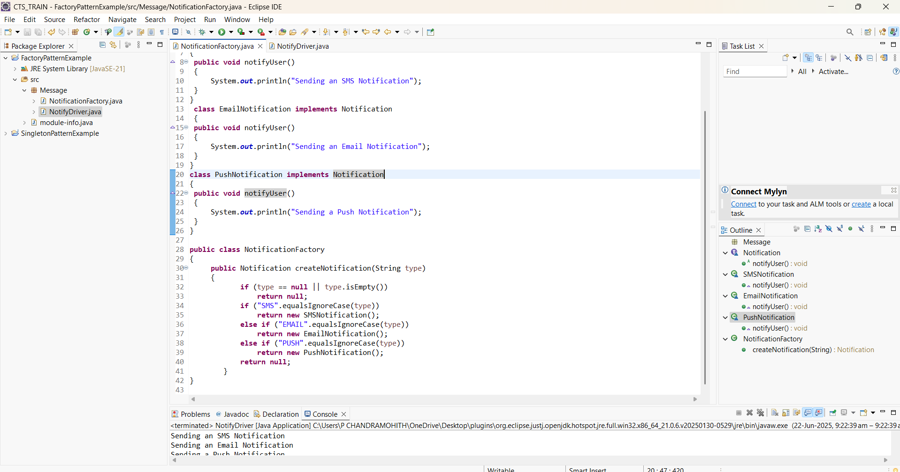

NotifyDriver.java

